Phrase-Structure Parsing

Source: https://people.ischool.berkeley.edu/~dbamman/nlp20_slides/14_phrase_structure_parsing.pdf

Chomsky Normal Form (CNF)
  - Weakly equivalent CFG
  - Convert using Cocke-Kasami-Younger (CYK) algorithm
    - Use to check if sentence is grammatically correct
    - Enumerate all possible parses for a sentence
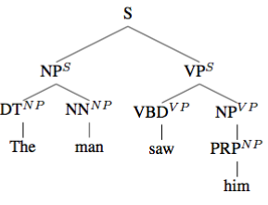
PCFG
- Limitation: independence assumption from production to rest of tree
- Can use parent annotation in tree to encode context which increases grammar and decreses training data

